1. Index.html checker

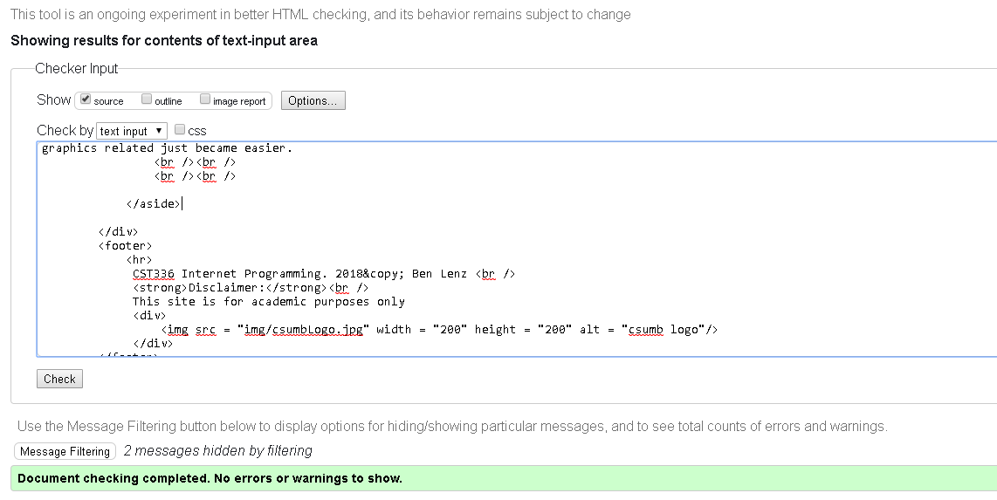

1. Cores.html checker

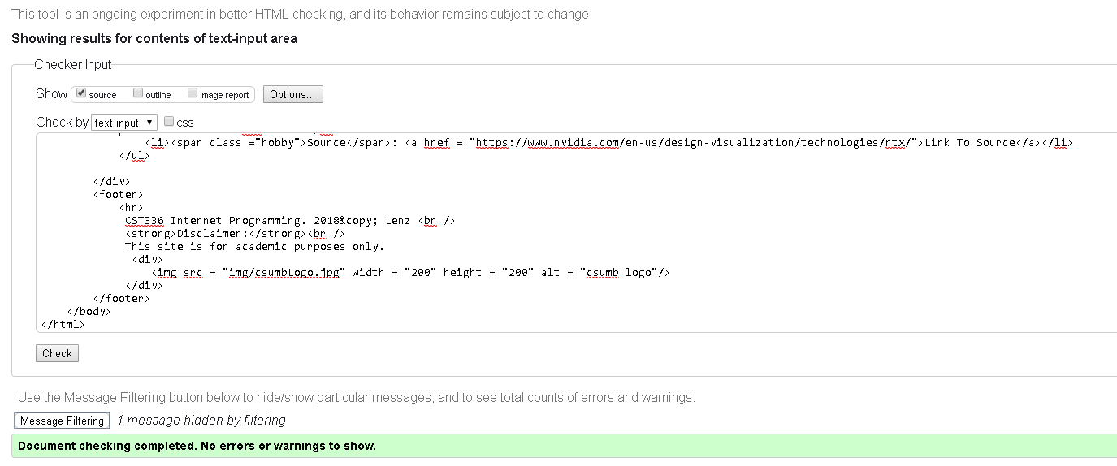

1. Tensor.html checker

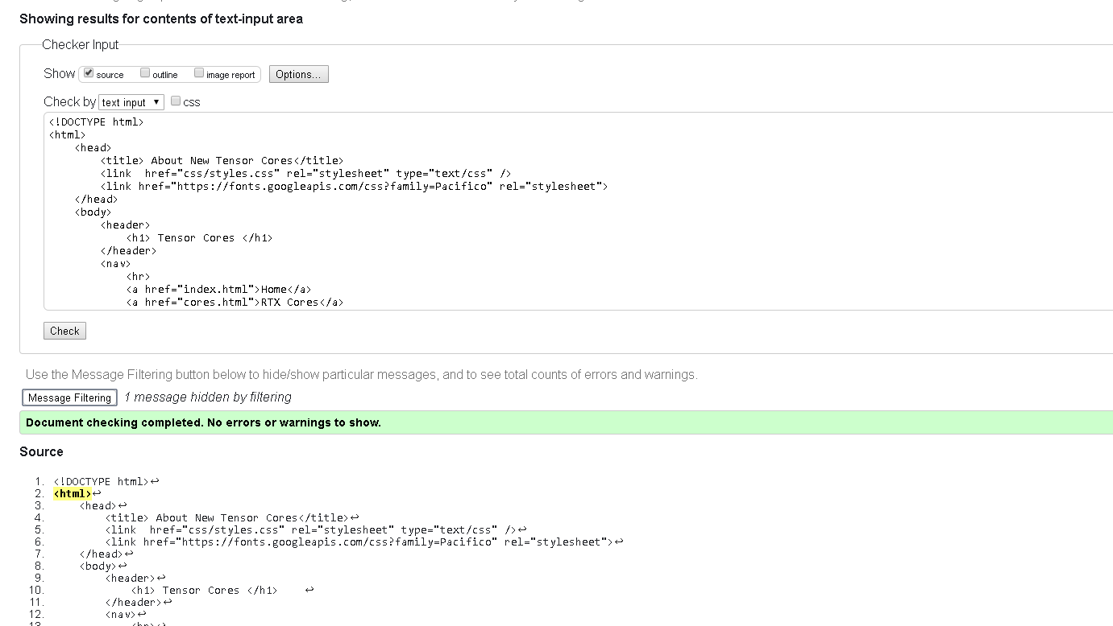

1. Stats.html checker

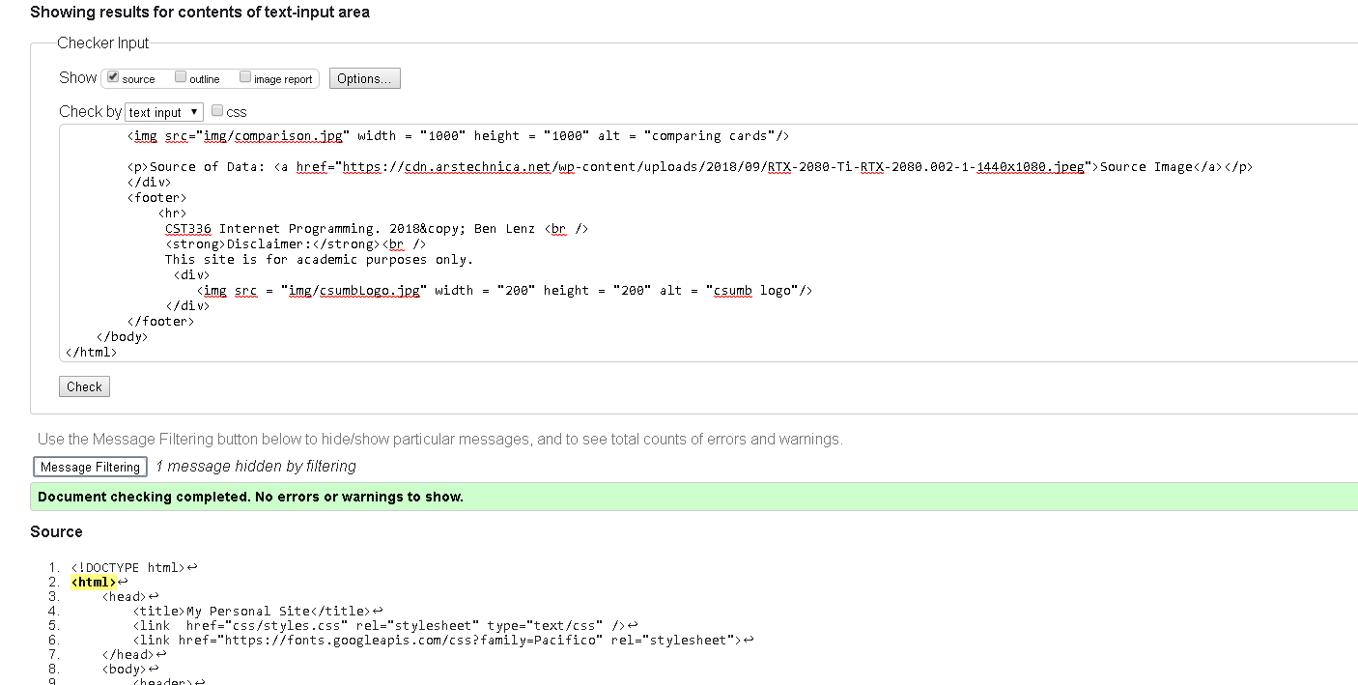

New HTML Tags used:

1. <p></p> paragraph tags are a simple way of storing text and keeping text boxes neat.
2. <h2></h2> new header tags used to help distinguish different sections

CSS Tags used:

1. Used CSS tag of p to style the paragraph used to display text.
2. Used new “id” elements to style specific objects on the page